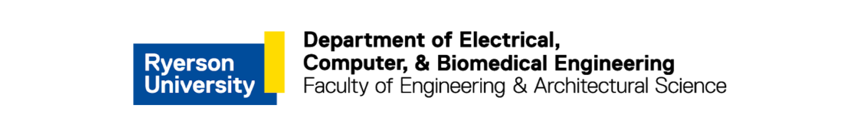

|  |  |
| --- | --- |
| **Course Title:** | Fundamentals of Data Engineering |
| **Course Number:** | COE 848 |
| **Semester/Year (e.g.F2016)** | W2021 |
|  |  |
| **Instructor:** | Dr. Faezeh Ensan |
|  |  |
|  |  |
| *Assignment/Lab Number:* | 3 |
| *Assignment/Lab Title:* | Database Design |
|  |  |
|  |  |
| *Submission Date:* | March 2, 2021 |
| *Due Date:* | March 2, 2021 |

|  |  |  |  |  |
| --- | --- | --- | --- | --- |
| **Student LAST Name** | **Student FIRST Name** | **Student Number** | **Section** | **Signature\*** |
| Shreekant | Vatsal | 500771363 | 01 | VS |

*\*By signing above you attest that you have contributed to this written lab report and confirm that all work you have contributed to this lab report is your own work. Any suspicion of copying or plagiarism in this work will result in an investigation of Academic Misconduct and may result in a “0” on the work, an “F” in the course, or possibly more severe penalties, as well as a Disciplinary Notice on your academic record under the Student Code of Academic Conduct, which can be found online at:* [*http://www.ryerson.ca/senate/current/pol60.pdf*](http://www.ryerson.ca/senate/current/pol60.pdf)

**Design of the Project:**

The objective of this data base is to document the various product orders via an e-commerce company like Amazon. Amazon has been known for quite some time now for it’s commercial success in it’s e-commerce operations dealing with millions of products everyday Using the ERD created in lab 2, the basic structures of the tables were created. Using NetBeans application, the database was constructed.

Figure 1: Entity-Relationship Diagram (ERD) of an e-commerce platform such as Amazon

Using Figure 1, the database schema was created in which primary keys will be underlined and foreign keys will be **bolded**. The relationships with the entities are also discussed.

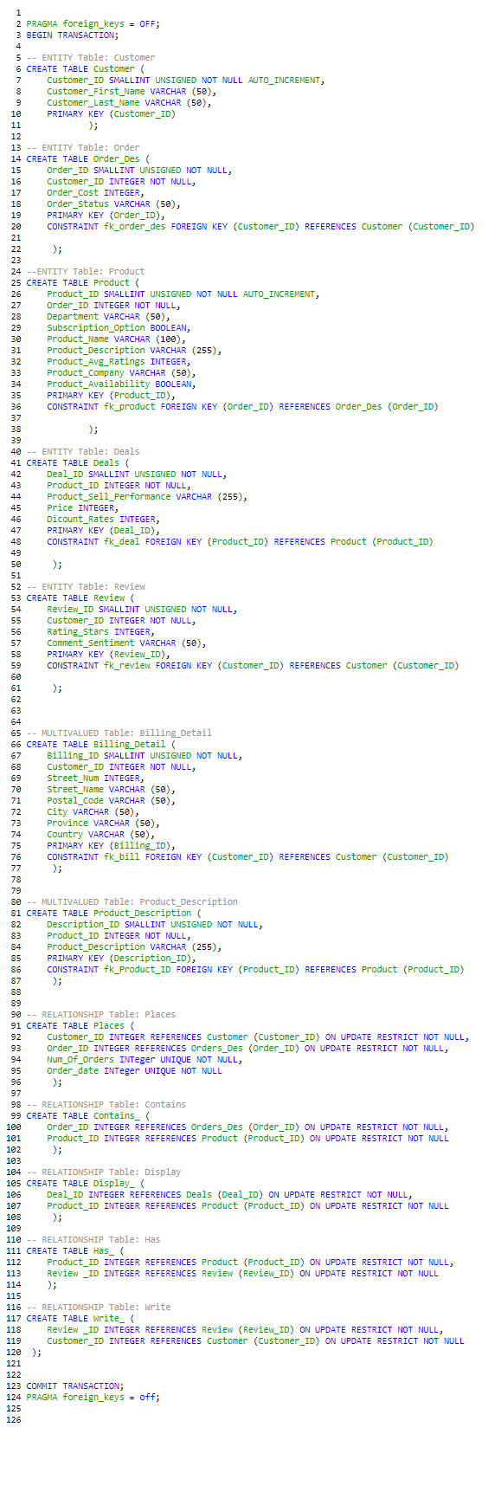

Figure 2: Tables Dump

**Entity Data Schemas:**

1. Customer(CustomerID, Customer_First_Name, Customer_Last_Name, Billing_Detail): The user that browses the product inventory and places an order.
2. Order(Order_ID, **CustomerID**, Order_Cost, Order_Status): The order placed by the user and the details.
3. Product(Product_ID, **Order_ID**, Product_Name, Product_Company, Product_Description, Product_Avg_Ratings, Subscription_Option, Product_Availability, Department): The item ordered by the user based on the rating, reviews, and discounts.
4. Review(Review_ID, **Product_ID**, Rating_Stars, Comment_Sentiment): The product feedback as provided by the customer along with the ratings.
5. Deals(Deal_ID, **Review_ID**, Product_Sell_Performance, Price, Discount_Rates): A discount-day like event that lists the popular product on sale.

**Relationship Data Schemas:**

1. Places(Customer to Order) (**Customer_ID**, **Order_ID**, Num_Of_Orders, Order_Date): A customer can place none or multiple orders. The order associated to each customer is unique and can only be 1 per customer.
2. Contains(Order to Product) (**Order_ID, Product_ID**): An order can contain have 1 or many products. A product can contain 0 or many orders.
3. Has(Product to Review) (**Product_ID, Review_ID**): A product has 0 or many reviews. A unique review only has 1 product associated.
4. Write(Review to Customer) (**Review_ID, Customer_ID)**: A customer can write 0 or many reviews. A review written by the customer is unique and can only be 1.
5. Display(Product to Deals) (**Deal_ID**, **Product_ID**): A deal can display 1 or many products. A product can be displayed on 0 or many deals.

**Attribute Data Schemas:**

Customer:

* Customer_ID: A unique ID assigned to each customer.
* Customer_First_Name: The customer’s first name.
* Customer_Last_Name: The customer’s last name.
* Billing_Detail: The billing details of the customer.
* Num_Of_Orders: Total number of orders placed by the customer.

Order:

* Order_ID: A unique ID assigned to each order placed.
* Order_Cost: The total cost of the order.
* Order_Date: The date the order was placed.
* Order_Status: The tracking information of the order.

Product:

* Product_ID: A unique ID assigned to each product as part of the inventory/database.
* Product_Name: The name of the product.
* Product_Company: The company that sells the product.
* Product_Description: A short description about the product.
* Product_Avg_Ratings: A five-star rating calculated as an average from the rating stars of the product as part of the reviews.
* Subscription_Option: A binary option selecting ‘yes’ or ‘no’ to a subscription service for the product.
* Product_Availability: The availability of the product.
* Department: The department the product belongs to.

Review:

* Review_ID: A unique ID assigned to each review.
* Rating_Stars: The rating stars associated with each review.
* Comment_Sentiment: A one-word review of the product as either: Good, Moderate or Bad.

Deals:

* Product_Sell_Performance: The performance of the best-selling and worst-selling products.
* Price: The price of the products after the applied discount.
* Discount_Rates: A percentage figure of the discount for each product.